# Lab 02 Answers

**Question no: 1**

**You are working at Toyota Indus Motors and want to assemble a car. Design a flowchart with proper**

**process modules and decision structures to replicate a pipeline production.**

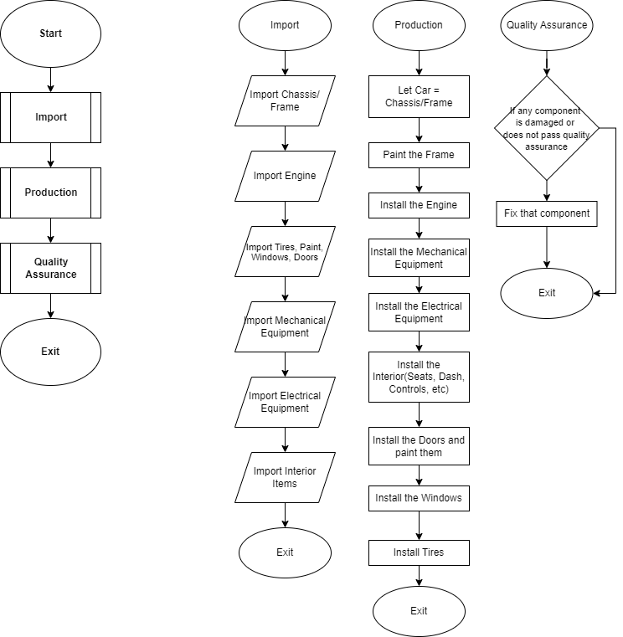

**Question no: 2**

***Find the maximum number in any of three variables.***

**Start**

**Input number1**

**Input number2**

**Input number3**

**If number1>number2 and number1>number3 Then**

**Print "Number 1 is greater"**

**Else If number2>number3 and number2>number1 Then**

**Print "Number 2 is greater"**

**Else**

**Print "Number 3 is greater"**

**End**

**Question no: 3**

***Take three variables as input and add them without using the + operator***

Start

Input number1

Input number2

Input number3

Set number2 = -1 * number2

Set number3 = -1 * number3

Set sum to 0

Set sum = number1 - number2 - number 3

Print sum

End

**Question no: 4**

***Create a small calculator which only does ‘+’ or ‘-‘Operations.***

**Start**

**Input number1**

**Input number2**

**Input operation**

**Set answer to 0**

**If operation == "Add" OR operation == "+" Then**

**Set answer = number1 + number2**

**Print answer**

**Else If operation == "Subtract" OR operation == "-"**

**Set Answer = number1 - number2**

**Print answer**

**Else**

**Print "Please enter 'Add', '+','Subtract','-' in the operator input"**

**End**

**Question no: 5**

***Implement an algorithm for determining if an Nth is a divisor of an n Number***

**Question no: 6**

***Implement an algorithm where the user enters a number, and an appropriate month is displayed.***

***Algorithm***

Ask the user to enter a number from 1-12 known as month number

If month number == 1 Then display "January"

If month number == 2 Then display "February"

If month number == 3 Then display "March"

If month number == 4 Then display "April"

If month number == 5 Then display "May"

If month number == 6 Then display "June"

If month number == 7 Then display "July"

If month number == 8 Then display "August"

If month number == 9 Then display "September"

If month number == 10 Then display "October"

If month number == 11 Then display "November"

If month number == 12 Then display "December"

If month number is not matched, Then display "Please enter a number in the range of 1-12"

***Pseudocode:***

Start

Input month number

If month number == 1 Then

Print "January"

Else If month number == 2 Then

Print "February"

Else If month number == 3 Then

Print "March"

Else If month number == 4 Then

Print "April"

Else If month number == 5 Then

Print "May"

Else If month number == 6 Then

Print "June"

Else If month number == 7 Then

Print "July"

Else If month number == 8 Then

Print "August"

Else If month number == 9 Then

Print "September"

Else If month number == 10 Then

Print "October"

Else If month number == 11 Then

Print "November"

Else If month number == 12 Then

Print "December"

Else

Print "Please enter a number in the range of 1-12"

End

**Question no: 7**

***Implement an algorithm for making a simple calculator with all the operators (+,-,*,/,%)***

***Algorithm***

**Ask the user for the first number**

**Ask the user for the operation (+,-,*,/)**

**Ask the user for the second number**

**Check if operation is equal to "+" , if this is true then continue this step, if not true then skip to next step**

**let Sum = first number + second number**

**Display "Sum"**

**Check if operation is equal to "-" , if this is true then continue this step, if not true then skip to next step**

**let Difference = first number - second number**

**Display "Difference"**

**Check if operation is equal to "*" , if this is true then continue this step, if not true then skip to next step**

**let Product = first number * second number**

**Display "Product"**

**Check if operation is equal to "/" , if this is true then continue this step, if not true then skip to next step**

**let Fraction = first number / second number**

**Display "Fraction"**

**If none of the conditions are met ask the user to Re-enter the operator**

***Pseudocode:***

**Start**

**Input firstno**

**Input operator**

**Input secondno**

**If operator == "+" Then**

**let sum = firstno + secondno**

**Print sum**

**Else if operator == "-" Then**

**let diff = firstno - secondno**

**Print diff**

**Else if operator == "*" Then**

**let product = firstno * secondno**

**Print product**

**Else if operator == "/" Then**

**let frac = firstno / secondno**

**Print frac**

**Else**

**Print "Please Re-Enter the operator (+,-,*,/)"**

**End**